Presbytery
6 Broompark Circus
Glasgow
G31 2JF

Tel: 0141 554 1558
Mob: 07910115868
e-mail: olgoodcounsel@rcag.org.uk

Parish Clergy
Fr Joseph Lappin
Rev Thomas Morrison
(Permanent Deacon)

www.ologc-gla.com
Twitter: @OLoGC_Glasgow

Father, almighty and eternal God, whose praise is sung throughout all creation and whose glory is proclaimed by all peoples. You create us in love and call us to our eternal destiny of loving communion with You. May the parish of Our Lady of Good Counsel be a place where Your Name is hallowed and Your chosen ones are united in Holy Mass with Your Son in praise and thanksgiving.
Lord Jesus Christ, Word of God, Incarnate of the Virgin Mary, You manifest the Father’s love and reveal His will for us. May we always be aware of our Baptismal dignity as the Children of God by our sharing through the Holy Spirit in Your Sonship, and so respond to Your call in service of each other, our parish, Holy Mother Church and the world.
Holy Spirit, Advocate and Spirit of Truth, You breathed your life into the Apostles at Pentecost, inspiring them to be preachers of the Word. May we always be open to Your promptings that our parish may be renewed in praise of God and in living the truth in charity.
Our Lady Mother of the Church
Our Lady of Good Counsel
Baptisms
Usually take place after the 11.00am Mass on Sunday. Parents are requested to make arrangements with the Parish Clergy in good time.

Marriages
Couples are requested to speak to the Parish Clergy at least six months before a wedding and before any other arrangements are confirmed.

Funerals
Families are asked to contact the Parish before making any arrangements with a Funeral Director.

St Vincent de Paul Society
Meets every Sunday after the 11.00am Mass. Its members keep regular contact with the sick and elderly and support parishioners in time of need.

Our Lady of Good Counsel is a parish of the Archdiocese of Glasgow, a Designated Religious Charity, No. SCO18140
INTIMATIONS
In charity we are asked to pray for:
Sick: All commended to our prayers.

Recently deceased:
Marianne Brennan; Margaret Fawcett; Catherine Cullen; May Murphy;

Anniversary:
Thomas Arnold; Martin Murray; Janette Rossini; Gerard Rice; Edward Hamilton;

The parish bulletin is sponsored by parishioner John Watters, painter & decorator. Free estimates 0141 554 7454
Our Lady of Good Counsel

15th SUNDAY OF THE YEAR
YEAR C
14th July 2019

Liturgy of the Word:
1st reading: Deut 30:10-14
Psalm 68; Response:
Seek the Lord, you who are poor,
and your hearts will revive.
2nd reading: 2 Tim 4:6-8.18-18
Gospel: Mt 16:13-19

Divine Office: Week 3

Feast Days:
Mon 15 July: Memorial of St Bonaventure

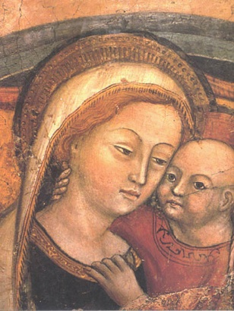

DATE FOR YOUR DIARY
There will be a parish meeting on Monday 26th August 2019 at 7.00pm in the parish hall. Further information to follow. Please note the date and make every effort to attend this meeting.

SACRAMENTAL PREPARATION
The parish programme of sacramental preparation will begin on Sunday 1st September. The parents of children who are due to receive the sacraments are invited to a meeting in the parish hall to enrol their child:
First Confession: Sunday 18th August 2019, 12.00pm
Holy Communion & Confirmation: Sunday 25th August 2019, 12.00pm.

CHURCH CLEANING
Sunday Masses
Vigil 5.30pm
11.00am; 5.30pm

Children’s Liturgy
is available during school term at the 11.00am Mass for children
primary 1 to 4.

Daily Mass: 10.00am
(Thursday: Liturgy of the Word)

Exposition of the Blessed Sacrament:
Friday after 10.00am Mass – 11.00am

Confessions:
Saturday after 10.00am Mass
4.30pm - 5.15pm

Some more volunteers are required to assist with the cleaning of the church. If you have some time to spare on a Monday morning your help will be appreciated.

BULLETIN
During the summer holidays the Bulletin will only be printed fortnightly.

SECOND COLLECTIONS
13/14th July: Apostleship of the Sea
Cruises have become a popular holiday but have you ever thought of those working below deck? Many of our favourite goods are imported on big tankards – who staffs these ships? And who cares for them? The Apostleship of the Sea offers faith support to staff on ships, many of whom may be a way from their home and family for many months at a time.

COLLECTIONS
Last week’s offertory collection came to £523
Many thanks for your ongoing support of the parish.

POPE FRANCIS TWEETS
In difficult times, even more than in times of peace, the priority for believers is to be united to Jesus, our hope.
@Pontifex

ST THERESE OF LISIEUX
Relics of St Therese of Lisieux will be present in Scotland in August and September this year. They will be in Glasgow 16-18th September.
After a stop in Barlinnie Prison, the relics will be taken to the parish of St Therese of Lisieux before being transferred to St Andrew’s Cathedral on 17th Sept, where there will be opportunity to venerate the relics of this most popular saint.
Full details of the programme can be found at:
www.littleflowerinscotland.co.uk/archdiocese-glasgow

PRO-LIFE MASS
This month’s Pro-Life Mass is on Wednesday, 17th July in Bl. John Duns Scotus, 270 Ballater St, Gorbals G5 0YT. There will be Adoration at 6pm, followed by Rosary at 7pm and Mass at 7.30pm. All welcome. The celebrant will be Fr Joseph Walsh.

FEAST OF ST. ANNE
26th July 2019. In St. Anne's Church, Whitevale Street, Dennistoun, the Novena to St. Anne will start on Wednesday 17th July with 7:00 pm Mass. Novena prayers will then be said each morning at the 9:30am. Mass. The Novena will conclude with Mass on Friday 26th July at 7:00pm. All welcome.

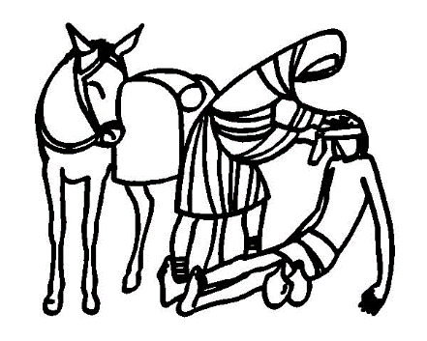
THE EVERLASTING FOODBANK
Donations are collected on the first Sunday of the month. This is a local, faith-motivated initiative to help those in need in our area and is worthy of our support.

GLASGOW FAIR
Perhaps not significant as in days past, nevertheless we wish you an enjoyable Fair Fortnight and Happy Holiday to those of you who are following tradition and taking your break from work now. With the melodious tones of TRNSMT filling the East End, surely escaping Glasgow this weekend was a good idea!

FERTILITY CARE SCOTLAND
We are opening a new clinic in the Diocesan offices, Paisley on alternative Monday evenings from 7 – 9pm. We run clinics in Edinburgh, Hamilton, Aberdeen and Paisley. At Fertility Care Scotland we teach The Billings Ovulation Method of Natural Fertility Regulation, which helps couples achieve or postpone pregnancy in a natural way. We can help couples optimize their chances of conceiving. Our service is free and confidential and no appointment is necessary. We invite you to come and visit us at one of our clinics. Phone: 0141 221 0858; E-Mail: info@fertilitycare.org.uk;www.fertilitycare.org.uk Join us on facebook
www.facebook.com/fertilitycarescotland Follow us on Twitter: www.twitter.com/billingsscot

HAVE YOU EVER CONSIDERED ADOPTION?
Have you ever considered adoption as a way to grow your family? Could you provide a loving, stable family environment for a child who needs a home? If you would like to find out more about the adoption process, please visit www.stmargaretsadoption.org.uk or contact us on 0141 332 8371 or e-mail info@stmargaretsadoption.org.uk.

VOCATION DISCERNMENT
A series of evening of catechesis, prayer and support has been organised for next year. Anyone considering their future and what God is calling them to do is welcome. The next meeting is at 7.00pm pm on Fri 10th May 2019 in Turnbull Hall, Southpark Terrace, G12 8LG.

